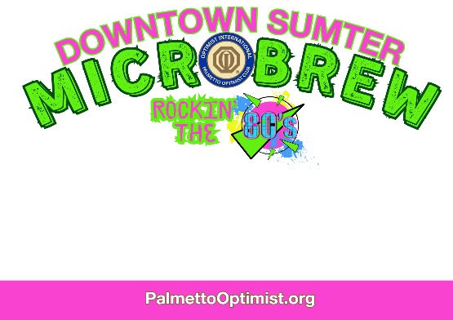

Mark your calendars for Saturday, May 10th, 2025, from 5-9:00 pm for the Downtown Sumter
Microbrew Festival, brought to you by the Palmetto Optimist Club, sponsored by the Yahnis Company, and helping the youth of Sumter. This year, pull out your leg warmers, parachute pants and hair spray because we’re going back to the ‘80s!

We are looking for 10-12 participating locations who will host 2 different microbrew beers from selected breweries that participants can taste. Each location will provide the following:
- Food for participants to sample as they stroll from business to business.
- Tables for the food and craft beers
- Decorations to reflect the 80s theme (not needed but adds to the fun!)
- At least 2 volunteers to serve microbrew samples.

If your business is interested in taking part in this year’s event, please send the form below on or before April 25th, 2024. Space is limited to 12 businesses so secure your spot early.

Thank you!
---------------------------------------------------------------------------------------------------------------------
Name: ________________________________________________________________________
Business: ______________________________________________________________________
Address: _______________________________________________________________________
Phone Number: _________________________________________________________________
Email Address: __________________________________________________________________
Each participant will receive a free bag, and all merchants are welcome to add a promotional item to the bag (such as a pen, pencil, magnet etc.). You would need to supply 300 of the items for the bag. Yes, I will provide______________________________ No________________

Please return form to:
Palmetto Optimist Club
1390 Malone Drive
Sumter, SC 29154
PalmettoOptimistClub@gmail.com
Questions? Call Linda (803) 236-4506

